**Calculator Free**

**The Natural Logarithm and Anti-Differentiation**

Time: 45 minutes

Total Marks: 45

Your Score: / 45



**Question One: [2, 3, 3 = 8 marks] CF**

Determine each of the following anti-derivatives, simplifying your answer where possible:

(a) 

(b) 

(c) 

**Question Two: [4, 4 = 8 marks] CF**

Calculate each of the following definite integrals, simplifying your answers using logarithmic laws.

(a) 

(b) 

**Question Three: [3, 4, 4 = 11 marks] CF**

Consider the function 

(a) Sketch the function on the axes below.

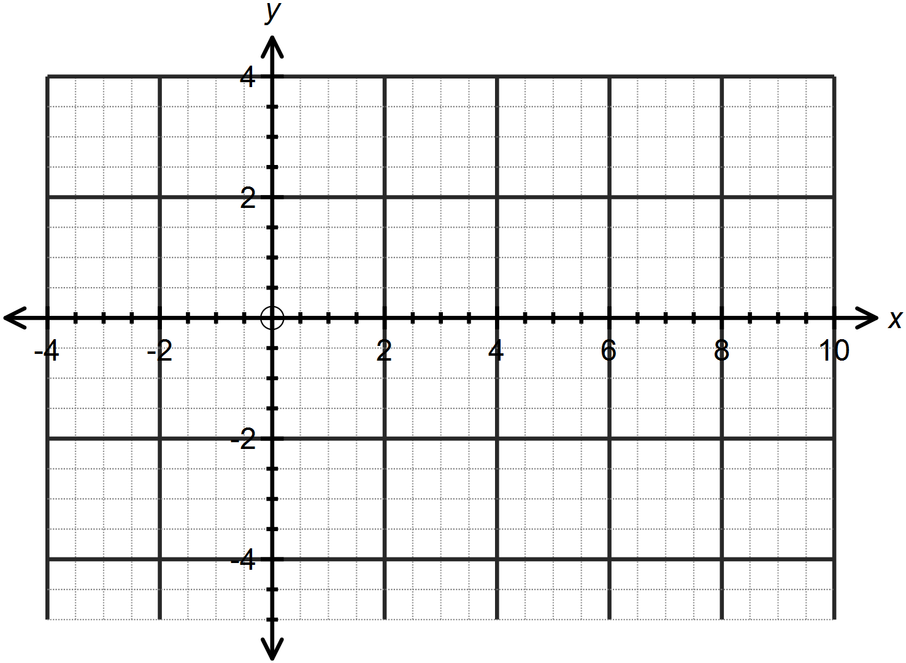

(b) Calculate the area bounded by the function,the *x –* axis and the lines  and  . Simplify your answer.

(c) Calculate the area bounded by the function, the *y* – axis and the lines  and  .

**Question Four: [4 marks] CF**

Show that the exponential rule used to calculate compound interest,  can be

written as  .

**Question Five: [3, 1, 1, 2, 2 =9 marks] CF**

Newton’s Law of Cooling allows us to monitor the rate at which the difference between the temperature of a body and its surrounds will cool over time.

This can be defined as:  where  is the difference between the temperature of the body and the surrounding room temperature and *t* is the time in minutes since the body was introduced to the room.

In order to find a rule modelling  in terms of *t*, we can first separate the variables as follows:



We can then integrate both sides, as follows:



(a) Integrate and equate each side to show that 

A pizza is removed from a 200˚C oven and put on the bench in a 25˚C room. After 5 minutes, the temperature of the pizza is 120˚C.

(b) Initially, what is the value of  ?

(c) After 5 minutes, what is the value of  ?

(d) Hence or otherwise determine the values of *k* and *c.*

(e) Hence determine when the pizza has reached room temperature.

**Question Six: [3, 2 = 5 marks] CF**

Synergy, the provider of electricity in Perth, monitor the maximum consumption of electricity over summer measured against the maximum temperatures.

Graphing the data provides us with the following graph, where *C* is maximum consumption in megawatts and *T* is the maximum temperature in degrees Celsius.

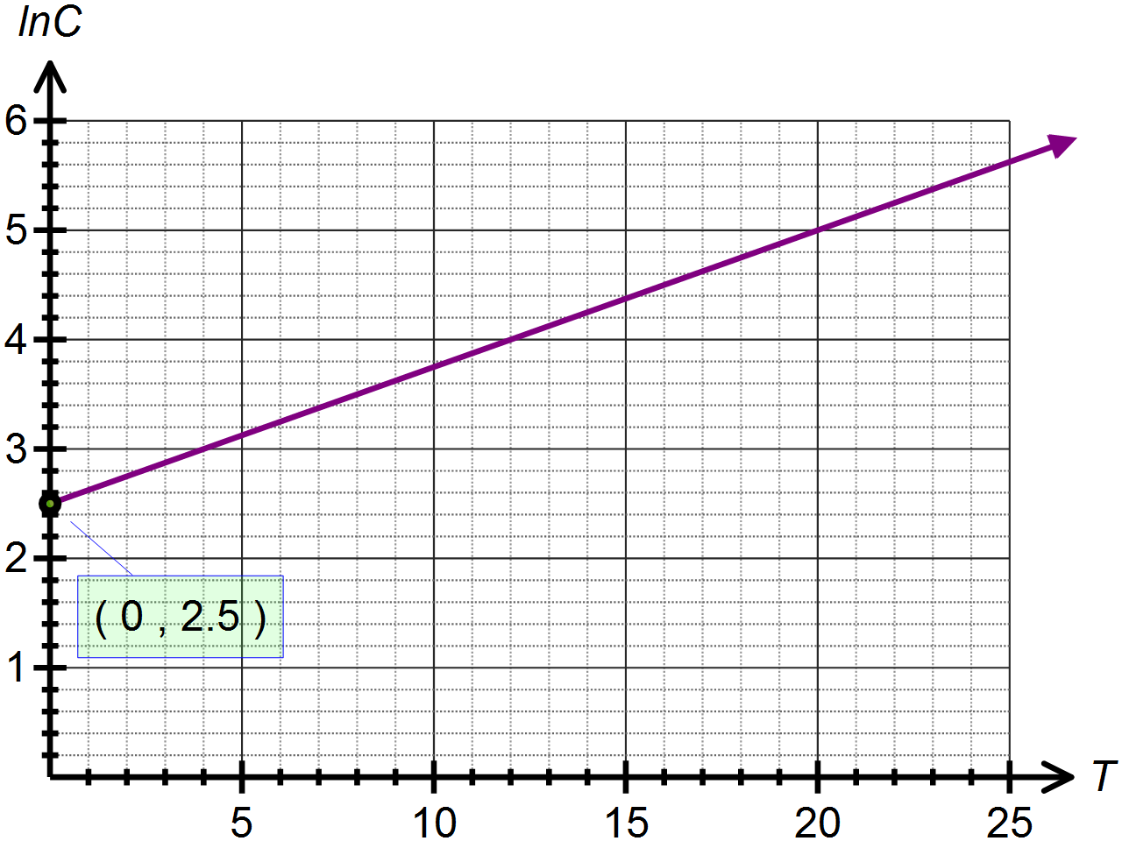

(a) Determine the equation of  in terms of  .

(b) Use your answer to (a) to determine the exponential function which models the energy consumption based on the maximum temperature recorded.

**SOLUTIONS**

**Calculator Free**

**The Natural Logarithm and Anti-Differentiation**

Time: 45 minutes

Total Marks: 45

Your Score: / 45



**Question One: [2, 3, 3 = 8 marks] CF**

Determine each of the following anti-derivatives, simplifying your answer where possible:

(a) 

 



(b) 



 



(c) 



 

**Question Two: [4, 4 = 8 marks] CF**

Calculate each of the following definite integrals, simplifying your answers using logarithmic laws.

(a) 



 

(b) 



 

**Question Three: [3, 4, 4 = 11 marks] CF**

Consider the function 

(a) Sketch the function on the axes below.



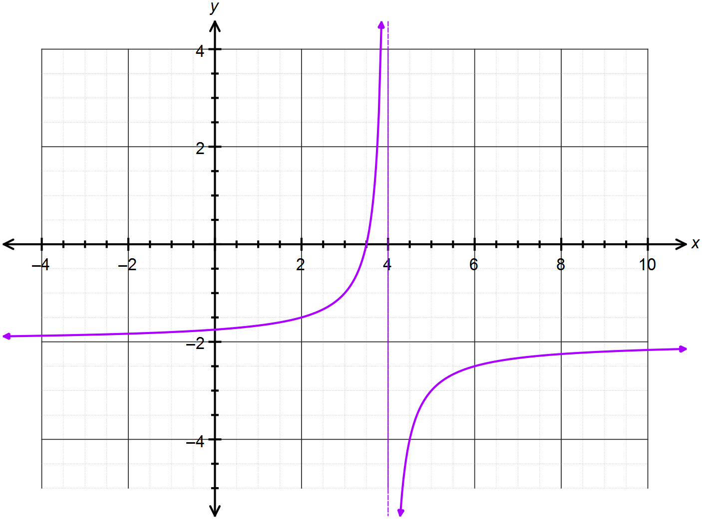





(b) Calculate the area bounded by the function, the *x –* axis and the lines  and  . Simplify your answer.

 

(c) Calculate the area bounded by the function, the *y* – axis and the lines  and  .



 

**Question Four: [4 marks] CF**

Show that the exponential rule used to calculate compound interest,  can be

written as  .





**Question Five: [3, 1, 1, 2, 2 =9 marks] CF**

Newton’s Law of Cooling allows us to monitor the rate at which the difference between the temperature of a body and its surrounds will cool over time.

This can be defined as:  where  is the difference between the temperature of the body and the surrounding room temperature and *t* is the time in minutes since the body was introduced to the room.

In order to find a rule modelling  in terms of *t*, we can first separate the variables as follows:



We can then integrate both sides, as follows:



(a) Integrate and equate each side to show that 

 

A pizza is removed from a 200˚C oven and put on the bench in a 25˚C room. After 5 minutes, the temperature of the pizza is 120˚C.

(b) Initially, what is the value of  ?

 

(c) After 5 minutes, what is the value of  ?





(d) Hence or otherwise determine the values of *k* and *c.*





(e) Hence determine when the pizza has reached room temperature.

 

**Question Six: [3, 2 = 5 marks] CF**

Synergy, the provider of electricity in Perth, monitor the maximum consumption of electricity over summer measured against the maximum temperatures.

Graphing the data provides us with the following graph, where *C* is maximum consumption in megawatts and *T* is the maximum temperature in degrees Celsius.



(a) Determine the equation of  in terms of  .



 

(b) Use your answer to (a) to determine the exponential function which models the energy consumption based on the maximum temperature recorded.

 